Linear Algebra

Laboratory Activity No. 10

Linear Transformations

|  |  |
| --- | --- |
| *Submitted by:* | *Instructor:* |
| Surio, Rovil Jr M. | Engr. Dylan Josh D. Lopez |

December 30, 2020

# Objectives

This laboratory activity aims to implement the principles and techniques of performing matrix operations or linear transformations such as repositioning, scaling, shearing, and rotation.

# Methods

The practice of the activity is to perform matrix operation and visualize repositioning, scaling, shearing, rotation on the given matrix using Python and NumPy. This implies and teaches the matrix operation needed to succeed in the linear transformation. The deliverables of the activity are to provide an example of linear transformation for a 2D space and visualize it using the vector fields.

# Results

The result after performing a matrix operation or linear transformation specifically the repositioning of vectors is presented in this section.

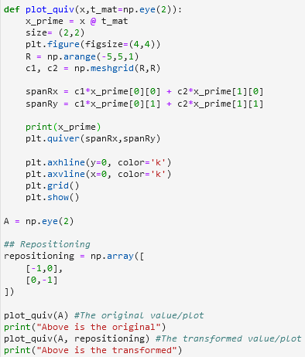

Figure 1 The code for repositioning

Figure 1 shows the code created for performing linear transformation specifically repositioning of vectors. The visualization used to observe the changes that happened is a vector field because it provides a more understandable graph than using a scatter plot.

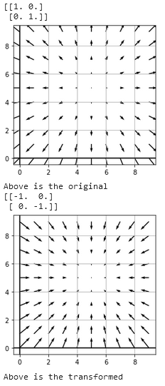

Figure 2 Vector fields visualization

Figure 2 shows the visualization of the transformed vector. The direction of the arrow represents the direction of the vector and in the example above, it shows that the direction of the arrow shifted 180 degrees because the transformation done is repositioning where in this case, the opposite integer value of the original vector is the transformed version of the original vector.

# Conclusion

The implementation of the principles and techniques of linear transformation was shown in this laboratory. I have learned how to transform a linear vector using matrix operations and how to visualize using a vector field. Moreover, the linear transformation is an important concept because it leaves the origin fixed and preserves parallelism [1] or in real-life, it’s concept is something like the base of everything, and the linear transformation it is like the other form of that based but technically the relationship of two still exist. For example, you have to leave your house to go to school, your house is the main data here while the school is considered to be the linear transformation data. From these data, you can observe the relationship between two locations that are related to you.

For several thousand years, people are preserving water using a different mechanism that makes the fluid move, and this possible because of different devices/equipment. In particular, a device called a pump is made for moving a fluid. “The pump utilizing a pressure difference, causing the fluid to move from an area of higher pressure to one of lower pressure” [2]. The linear transformation concept in the movement of the pump is the distance of its movement from its origin to utilize the pressure difference. Thus, the main location of the pump before it pumps or moves is the origin wherein the transformed version is its movement to move the fluid.

**References**

[1]M. Mas, "Linear transformations in Numpy", *Modesto Mas | Blog*, 2020. [Online]. Available: https://mmas.github.io/linear-transformations-numpy. [Accessed: 20- Dec- 2020].

[2]"Real-life applications - Fluid Mechanics - Bernoullis Principle in Action, Creating a draft", *Scienceclarified.com*, 2020. [Online]. Available: http://www.scienceclarified.com/everyday/Real-Life-Chemistry-Vol-3-Physics-Vol-1/Fluid-Mechanics-Real-life-applications.html. [Accessed: 20- Dec- 2020].

**Appendix**

This is the GitHub Repository https://github.com/RovilSurioJr/Laboratory-10